XMLaw Specification: version 1.0
Rodrigo B. Paes, Gustavo R. Carvalho, Carlos J. P. Lucena, Maíra A. C. Gatti
{rbp,guga,lucena,mgatti}@inf.puc-rio.br

Scope
The goal of this document is to specify the elements that compose the XMLaw conceptual model. This document was based on the structure used to specify the UML Error: Reference source not found. XMLaw has many extensions that have served to particular domains, such as criticality analysis [] and tests []. It is out of the scope of this document to detail these extensions.

Conventions
Enumeration
Syntax: {element1, element2, ..., elementN}
Semantics: An enumeration attribute may assume any value defined in between the braces.
Multiplicity
[1]: exactly one;
[0..1]: zero or one;
[1..*]: at least one;
[0..*]: any number of elements.

XMLaw conceptual model
Figure depicts the elements that compose the conceptual model of XMLaw. These elements are described in details in the following sections of this paper.
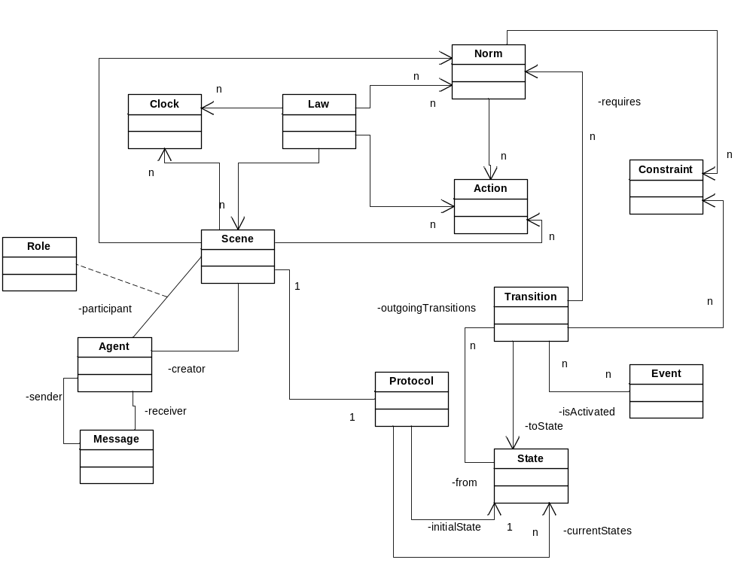
Figure 1 – XMLaw conceptual model.

Protocol

Description
A protocol is a nondeterministic finite state automaton (P) defined by the 5-tuple:
M= (E, S, T, s0, F)
Where:
E: a finite set of input symbols, which is composed of the events generated by XMLaw (see Section 0 for a complete list of events);
S: a finite set of states;
T: a transition function defined as:
T: E X S → 2^{S}
s0: a state s0, distinguished as initial state and in which s0 belongs to S;
F: a set of states, distinguished as final and in which F is a subset of S.

Attributes
name: String | The name of the protocol

Associations
initialState: State[1] | Initial state. Each protocol has only one initial state.
currentStates: State[1..*] | Set of current states. Due to the nondeterminism, a protocol can have a set of possible (current) states during its execution.

Semantic
A protocol defines the possible states that an agent interaction can evolve. Transitions between states can be fired by any XMLaw event, instead only messages arrivals. Therefore, protocols specify the expected sequence of events in the path of interaction among the agents.
A non-deterministic finite automaton Error: Reference source not found stops after consuming all the input symbols, and it provides two outputs:
- ACCEPT, if at the end of the processing there is at leat one final state in the set of possible states; or
- REJECT, when at the end of the processing thre is no final state in the set of possible states.
In this sense, a finite automaton does no stop when it reaches a final state, but it stops when there is no more input symbols to read. On the other hand, in an open system agents may be sending messages indefinably, and then, there is no way to determine if there are more input symbols to read. For this reason, the protocol defined in XMLaw also assumes that the input (represented by XMLaw events) is potentially infinity, and therefore it is not possible to determine when it finishes. However, as the output of the protocol depends on our ability to determine if there is a final state in the set of possible states at the end of the processing, but we do not know when the end of the process is achieved, how can we determine if the input is accepted or rejected? To avoid this problem, the protocol defined in XMLaw stops when a final state is reached, and the output is determined by the type of final state, which can be a success or failure.

Generated Events
There are no generated events.

Style Guide
There is no style guide.

Examples
There are no examples.

State

Description
A state models a possible step of evolution of the agents interfzaction. States can represent static or dynamic situations such as “waiting for buyer’s answer”, “deciding about the deal”, and so on.

Attributes
type: {successful, failure, execution} | Successful states mean that the protocol stops with success when it is reached.  Failure states mean that the protocol stops with failure when the state is reached.  When reached, execution states do not stop the protocol.
initial:Boolean | It is true if the state is the initial state. It is allowed only one initial state per protocol.
label: String | A meaningful name for the state.

Associations
outgoingTransitions: Transition[0..*] | List of transitions that outgoing from the state.

Semantic
A state may be active or inactive during the protocol execution. It is active when it belongs to the set of current states of the protocol, otherwise it is considered inactive.
A successful state is a final state that models a situation where interactions reached a desired situation and in which the protocol can stop its execution. For example, in a negotiation protocol there can be a successful state modeling that the negotiation has finished with the purchase of a certain item.
A failure state is a final state that happens when the interaction reaches a point where it is considered that the goal of the protocol has failed. For example, in the case of a negotiation protocol there can be a state modeling the situation where the item was not available, and therefore the protocol has failed to reach its goal (have an item bought, for example).
An execution state represents non-conclusive states, or in other words, they are intermediary steps in order to reach a final state.

Notation

Generated Events
failure_state_reached | This event is generated when a failure state is reached.
successful_state_reached | Geenerated when a successful state is reached.

Style Guide

Examples

Transition

Description
A transition is a directed arc between a source state and an end state. It represents the change between two different situations in the course of the interactions caused by a response to the occurrence of an XMLaw event.

Attributes
event: Event | Refers to the event that causes this transition to fire. In most of the cases this event is the arrival of a message.

Associations
from: State[1] | Source state
to: State[1] | End state
requiredNorms: Norm[0..*] | These are references to norms declared in the scope of the scene or in the scope of the law. It means that the transition requires the norms to be active and valid in order to fire.
constraints: Constraint[0..*] | Represent constraints that verify if the transition should fire. These constraints act as a filter.

Semantic
When a transition is fired, the end state is added to the list of current states of the protocol. A transition has only one source state and one end state. However, the same state may contain many transitions to different states. Transitions depend on the requiredNorms and constraints attributes in order to fire. The requiredNorms attribute models situations where it is necessary to have a certain norm to fire the transition. For example, in a team of buyers, the manager is the only one to have the permission to ask the bank (modeled as a transition activated by the message) for more money. Constraints may act as fine grained filters for transitions. A constraint could access a database, do some math, calculate date periods or any other complex domain-dependent operation in order to let the transition fire.

Notation

Generated Events
transition_activation | Generated when the transition is fired.

Style Guide

Examples

Event

Description
An event is a representation of an occurrence in the law. An event can be generated and sensed by law elements that can react to it.

Attributes
generatorId: Id | Identification of the law element that generated the event. For example, if the event is a transition_activation, the generatorId holds the id of the transition.
type: {message_arrival, compliant_message, transition_activation, failure_state_reached, successful_state_reached, failure_scene_completion, sucessful_scene_completion, time_to_live_elapsed, clock_activation, clock_tick, clock_timeout, clock_deactivation, norm_activation, norm_deactivation, scene_creation, action_activation, constraint_activation} | Identifies the type of event.

Associations
There is no association.

Semantic
An event models an occurrence related to the elements of the law. It can represent a change of state of a protocol, the arrival of a message sent by an agent, the moment in which an agent acquires an obligation, an announcement that a certain amount of time has been elapsed and many others. The semantic of each event is determined by its type. There are many types of events, which are summarized as follows.
message_arrival | Represents that an agent has sent a message and this message has been intercepted by the mediator.
compliant_message | Represents that the message matches with the message pattern expected in the law.
transition_activation | Represents when there is a change of state in the protocol, i.e., the transition that connects the two states has fired.
failure_state_reached | Represents when the protocol reaches a failure state, i.e., the transition function of the protocol has generated a list of possible states in which a failure state belongs to.
successful_state_reached | Represents when the protocol reaches a successful state, i.e., the transition function of the protocol has generated a list of possible states in which a successful state belongs to.
failure_scene_completion | Represents that a scene has ended with failure because its protocol has generated a failure_state_reached.
sucessful_scene_completion | Represents that a scene has ended with success because its protocol has generated a successful_state_reached.
scene_creation | A scene is created
time_to_live_elapsed | The scene has been running t+1 milliseconds more than the time to live attribute specified in the scene and the scene is dead (not running any more).
clock_activation | A clock has been activated and it has started to count the time.
clock_tick | A cycle with the duration specified in the tick-period attribute of a clock has elapsed.
clock_timeout | It happens when a “once” clock has generated a clock-tick event and, therefore, finished its execution.
clock_deactivation | Happens when any of the deactivation conditions specified in the clock occur, and therefore the clock execution is interrupted.
norm_activation | A norm is activated
norm_deactivation | A norm is deactivated due to its deactivation conditions
action_activation | An action is executed

Notation

Generated Events
Not applicable.

Style Guide

Examples

Scene

Description
The notion of scene presented here is based on the work done in Electronic Institutions []. The idea of scenes is similar to theater plays, where actors play according to well defined scripts, and the whole play is composed of many scenes sequentially connected.

Attributes
time-to-live: long | Time specified in milliseconds that means the maximum amount of time the scene is supposed to last. If the scene stills running for more than the specified time, than a time-to-live event is generated.  There is a special case where this attribute can be specified as the literal string “infinity”, which means that the scene never expires.

Associations
protocol: Protocol[1] | The protocol that specifies the possible flows of interaction in the scene.
actions: Action[0..*] | Actions that can be executed in the context of scene. These actions only sense and generate events in the scope of the scene.
norms: Norm[0..*] | Norms that exist in the context of the scene.
clocks: Clock[0..*] | Clocks declared in the context of the scene.
participants: Participant[0..*] | List of participants that are able to enter in the scene. The Participant class is not part of the elements that compose the conceptual model. However its structure is defined in Section 17.2.
creators: Creator[0..*] | Specifies which agents can start the scene. The Creator class is not part of the elements that compose the conceptual model. However its structure is defined in Section 17.3.

Semantic
A scene models a context of interaction where a protocol, actions, clocks and norms can be composed to represent complex normative situations. Furthermore, from the problem modeling point of view, a scene allows for the decomposition of the problem in smaller and more manageable pieces of information. They can viewed as building blocks of normative interactions. By normative interactions is meant to be a situation where agents are interacting under a set of behavioral rules, or social conventions.

Life Cycle
Copiar algum lugar que a gente já fez isso.

Notation
There is no notation for this element.

Generated Events
scene_creation | A scene is created
time_to_live_elapsed | The scene has been running t+1 milliseconds more than the time to live attribute specified in the scene and the scene is dead (not running any more).
failure_scene_completion | Represents that a scene has ended with failure because its protocol has generated a failure_state_reached.
sucessful_scene_completion | Represents that a scene has ended with success because its protocol has generated a successful_state_reached.

Style Guide
There is no style guide for this element.

Examples
There is no examples for this element.

Clock

Description
Clocks represent time restrictions or controls and they can be used to activate other law elements. Clocks indicate that a certain period has elapsed producing clock-tick events. Once activated, a clock can generate clock-tick events. Clocks are activated and deactivated by law elements.

Attributes
type: {periodic, once} | There are two types of clock: the “once” generates just one event after a certain amount of time has elapsed, and the “periodic” cyclically generates events at a specific interval of time
tick-period: long | Specifies an amount of time in milliseconds. This time is used by the clock to generate clock-tick events.

Associations
activations: Event[0..*] | The events that activate the clock.
deactivations: Event[0..*] | The events that deactivate the clock.

Semantic

Life Cycle
Copiar algum lugar que a gente já fez isso.

Notation
There is no notation.

Generated Events
clock_activation | A clock has been activated and it has started to count the time.
clock_timeout | It happens when a “once” clock has generated a clock-tick event and, therefore, finished its execution.
clock_tick | A cycle with the duration specified in the tick-period attribute of a clock has elapsed.
clock_deactivation | Happens when any of the deactivation conditions specified in the clock occur, and therefore the clock execution is interrupted.

Style Guide
There is no style guide.

Examples
There are no examples.

Action

Description
Actions are domain-specific Java codes that run integrated with XMLaw specifications. Actions can be used to plug services in an environment. For instance, an environment can call a debit service from a bank agent to automatically charge the purchase of an item during a negotiation. In this case, we specify in the XMLaw that there is a class that is able to perform the debit.

Attributes
class: String[1] | The name of the domain-specific java class.

Associations
activations: Event[0..*] | The events that activate the action

Semantic
Since actions are also XMLaw elements, they can be activated by any event such as transition activation, norm activation and even action activation. The class attribute of an Action specifies the java class in charge of the functionality implementation. The Element tag references the events that activate this action, and as many Element tags as needed can be defined to trigger an action.
An action can be defined in three different scopes: Organization, Scene and Norms. An action defined in a Norm is only visible at this level. This means that any element in this scope can reference events issued by this action and that this action can get and update information at this level and upper levels. Actions defined in the scene scope can be referenced by any element at this level. And actions defined in the organization scope are visible to all elements at this level.

Notation
There is no notation.

Generated Events
There are no generated events.

Style Guide
There is no style guide.

Examples
There are no examples.

Constraint

Description
Constraints are restrictions over norms or transitions and generally specify filters for events, constraining the allowed values for a specific attribute of an event. For instance, messages carry information that is enforced in various ways. A message pattern enforces the message structure fields Error: Reference source not found. A message pattern does not describe what the allowed values for specific attributes are, but constraints can be used for this purpose. In this way, developers are free to build as complex constraints as needed for their applications.

Attributes
class: String[1] | The name of the domain-specific java class.

Associations
There are no associations.

Semantic
Constraints are defined inside the Transition or Norm elements. Constraints are implemented using Java code. The Constraint element defines the class attribute that indicates the java class that implements the filter. The use of Java code allows for the specification of complex user defined filter implementation. This class is called when a transition or a norm is supposed to fire, and basically the constraint analyzes if the message values or any other events’ attributes are valid.
A constrain implemented in the Java code must implement a method named “constrain(Set params):boolean”, if this method returns true, then it means that the filter was applied. In the case where a constraint is used with a transition, if the filter is applied, then the transition does not fire.

Notation
There is no notation.

Generated Events
constraint_activation | A constraint is executed and its “constrains” method returns true.

Style Guide
There is no style guide.

Examples
There are no examples.

Norm

Description
There are three types of norms in XMLaw: obligations, permissions and prohibitions. The obligation norm defines a commitment that software agents acquire while interacting with other entities. For instance, the winner of an auction is obligated to pay the committed value and this commitment might contain some penalties to avoid breaking this rule. The permission norm defines the rights of a software agent at a given moment, e.g. the winner of an auction has permission to interact with a bank provider through a payment protocol. Finally, the prohibition norm defines forbidden actions of a software agent at a given moment; for instance, if an agent does not pay its debts, it will not be allowed future participation in a scene.

Attributes
type: {permission, obligation, prohibition} | The type of norm.

Associations
assignee: Assignee[1] | The agent that is going to receive the norm. The structure of the assignee is described in Section 17.1.
activations: Event[0..*] | The events that activate the nom.
deactivations: Event[0..*] | The events that deactivate the norm in case of the norm is activated.
constraints: Constraint[0..*] | While the constraints do not “constrain”, i.e., while this “constrain” returns false (see Section 11.4 for details), the norm is still valid. When one of the constraints returns true, then the norm is not considered valid anymore.
actions: Action[0..*] | The set of actions that will be executed independently of each other while the norm is still valid and the activation events of the actions occur.

Semantic
The structure of the Permission, Obligation and Prohibition elements are equal. Each type of norm contains activation and deactivation conditions. Norms define the agent role that owns it through the association assignee. Norms also have constraints and actions associated with them. Norms also generate activation and deactivation events. For instance, as a consequence of the relationship between norms and transitions, it is possible to specify which norms must be made active or deactivated for firing a transition. In this sense, a transition could only fire if the sender agent has a specific norm.
The constraints allows for the definition of norms that are valid depending of the execution context. For example, one can define a constraint to check the amount of items of a certain good in the database to see if the agent has the permission to buy more items. In this case, while the amount of items is still in a certain limit, the permission is not valid, and when this limit is crossed, the permission become valid.
While a norm is in its valid state, its set of actions can be executed. Each action can be executed independently of the others. Actions will be executed when the event specified in their list of activation events occur.

Life Cycle
Deactivated – When
Active
Valid
Not-Valid

Notation
There is no notation.

Generated Events
There are no generated events.

Style Guide
There is no style guide.

Examples
There are no examples.

Agent

Description
It represents a software agent that is interacting with the other agents under the rules of the law. There is no assumption about what language or architecture agents are implemented.

Attributes
identification: String[0..1] | A unique identification of the agent. This attribute is optional because usually the laws are specified independently of the agent, but considering only the roles. For example, a norm could state: “A buyer is obligated to pay for the good in a period of at most 2 days”. This norm has no reference to a particular agent, instead it is general for all agents playing the buyer role.

Associations
message: Message[0..*] | The set of messages sent by the agent. This attribute is not specified a priori, because it is not possible to known a priori what messages an agent will send. However, it is present in the conceptual model because as multi-agent systems are mostly about interacting entities, it is important to make clear the relationship between agents and messages.
roles: Role[0..*] | An agent can play many roles while interacting. In order to interact in a scene, it is necessary identify which role the agent is playing for applying the norms and other law elements accordingly.

Semantic
The agent element can be used to represent a specific known agent. For example, one can specify a law considering that one of the agents is the “Bank of Money Agent”, and the write rules such: “The Bank of Money Agent” can order items costing more than a million dollars.

Notation
There is no notation.

Generated Events
There are no generated events.

Style Guide
There is no style guide.

Examples
There are no examples.

Message

Description
It models a message exchanged among agents. A message is defined as:
M={U,I,S,SR,R,C,P}
Where,
U: is a performative or communicative act uttered in the message;
I: is the identification for the conversation;
S: is the identification of the sender agent;
SR: is the role played by the sender agent while sending this message;
R: is a set of receivers identified by pairs of values {ReceiverAgent, ReceiverAgentRole};
C: is the content of the message;
P: is the name of the interaction protocol being followed, if any.

Attributes
performative: String[1] | The performative.
content: Content[0..*] | A map of pairs key-value that specify the contents of the message.
sender: AgentRole[1] | The sender. The structure of the AgentRole can be found in Section 17.4.
receivers: AgentRole[1..*] | The receivers. The structure of the AgentRole can be found in Section 17.4

Associations
There are no associations.

Semantic
There is no semantic.

Notation
There is no notation.

Generated Events
message_arival | Generated when a message sent by an agent reaches the mediator (or any other infrastructure in charge of monitoring the interactions for applying the laws).

Style Guide
There is no style guide.

Examples
There are no examples.

Role

Description
The role element is in the conceptual model due to its importance in the specification of laws. Usually, laws are specified considering roles of agents instead of agents themselves. A role is a domain-specific representation of the responsibilities, abilities and expected behavior of an agent. It is useful to abstract away from the individuals that are playing the role.

Attributes
There are no attributes.

Associations
There are no associations.

Semantic
There is no semantic.

Notation
There is no notation.

Generated Events
There are no generated events.

Style Guide
There is no style guide.

Examples
There are no examples.

Law

Description
The Law element is a context where all the other elements can be grouped. This is the most general element, and it does not belong to no other element.

Attributes
name: String[1] | The name of the law

Associations
scenes: Scene[0..*] | All scenes that are part of this law.
actions: Action[0..*] | Actions that can be executed in the context of law. These actions only sense and generate events in the scope of the law and all its inner scenes.
norms: Norm[0..*] | Norms that exist in the context of the law.
clocks: Clock[0..*] | Clocks declared in the context of the law.

Semantic
The Law element encapsulates a set of rules or laws. A law is composed of actions, norms, clocks and scenes. The scene element by its turn can also be composed of actions, norms and clocks. Then, one can use the law element to group together close related scenes, and use the norms, clocks and actions to capture behavior that cross the boundaries of a unique scene. For example, if in one scene an agent does not comply to a very severe rule, then he could be punished with a prohibition to interact in any scene. This prohibition can be specified in the context of the Law element, and be accessible from all scenes.

Notation
There is no notation.

Generated Events
There are no generated events.

Style Guide
There is no style guide.

Examples
There are no examples.

Auxiliary Elements

Assignee
roleRef: String[1] | It is a reference to the role of the agent that is receiving the norm.

Participant
agent: Agent[0..1]; | Optionally, it is possible to specify the specific agent that is allowed to enter in the scene. If no specific agent is specified, then the validation only takes into account the specified role.
role: Role[0..1]; | Specifies the agent role that is allowed to enter in the scene. If no role is specified, it is assumed that any role ca enter in it.
states: State[0..*]; | Specifies in which states of the protocol the agent specified playing the specified role can enter in the scene. If no state is specified, then it is possible to enter in any state.

Creator
agent: Agent[0..1];. | Optionally, it is possible to specify the specific agent that is allowed to start the scene. If no specific agent is specified, then the validation only takes into account the specified role
role: Role[0..1]; | Specifies the agent role that is allowed to create the scene. If no role is specified, it is assumed that any role can create it.

AgentRole
agent: Agent[0..1];. | Optionally, it is possible to specify the specific agent that is allowed to send the message. If no specific agent is specified, then the validation only takes into account the specified role
role: Role[0..1]; | Specifies the agent role that is allowed to send the message. If no role is specified, it is assumed that any role can send it.

Referências
- http://teia.inf.ufrgs.br/cgi-bin/moore.pl?curso=LivroAnimado&estado=53
- Unified Modeling Language: Superstructure, version 2.0 formal/05-07-04
- Paes, R.B., Carvalho G.R., Lucena, C.J.P., Alencar, P.S.C., Almeida H.O., Silva, V.T.: Specifying Laws in Open Multi-Agent Systems. In: Agents, Norms and Institutions for Regulated Multi-agent Systems (ANIREM), AAMAS2005. (2005)

